My Focus Bear issue
- I feel like hiding the tutorial in the ‘Help & Support’ section which is placed on the bottom-right corner of the app makes it very unlikely for people to click on it especially those who have ADHD. The tutorial should be available in every page and with more visibility. For example, putting a question mark icon on the top right of the page.
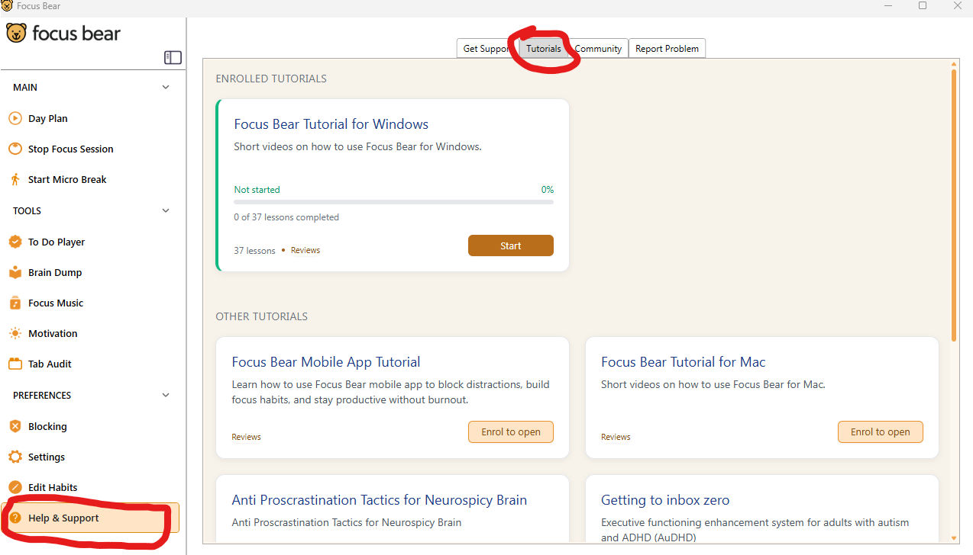
Figure 1 Help & Support

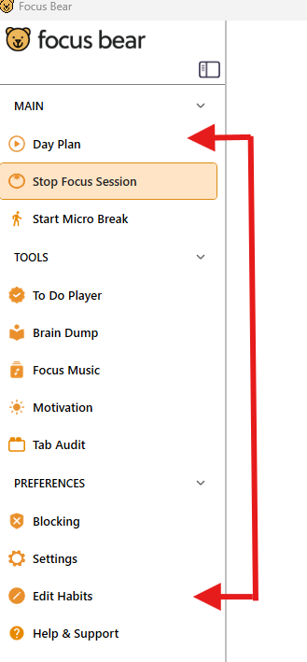
- Why is the day plan and edit habits which are the same feature in two different tabs? I feel that each feature should be in the same tab or section so it is more organized. Splitting them apart makes it annoying to switch between them. Giving the day plan page a button to open up a form to edit the habits would make things more organized. If they was a mistake to the habits, users can edit it on the spot.
Figure 2 Day Plan and Edit Habits

- The focus session when it started and the micro breaks tabs can just be together if they don’t take much space. There are so much empty spaces it might as well be use for something. Micro breaks tabs are mostly empty at all times anyway. This way would save more space to put another feature or tab.
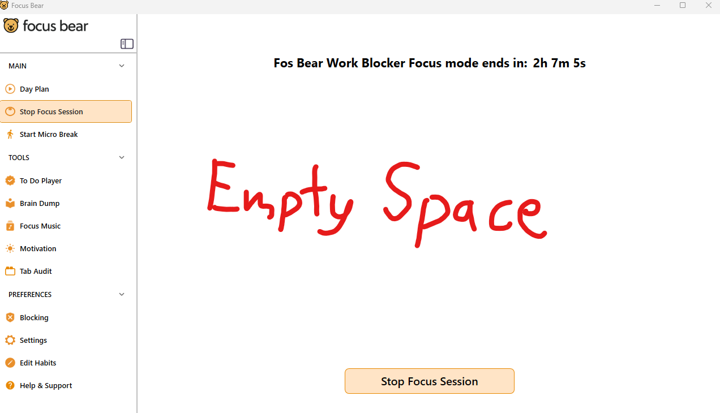
Figure 3 Focus Session
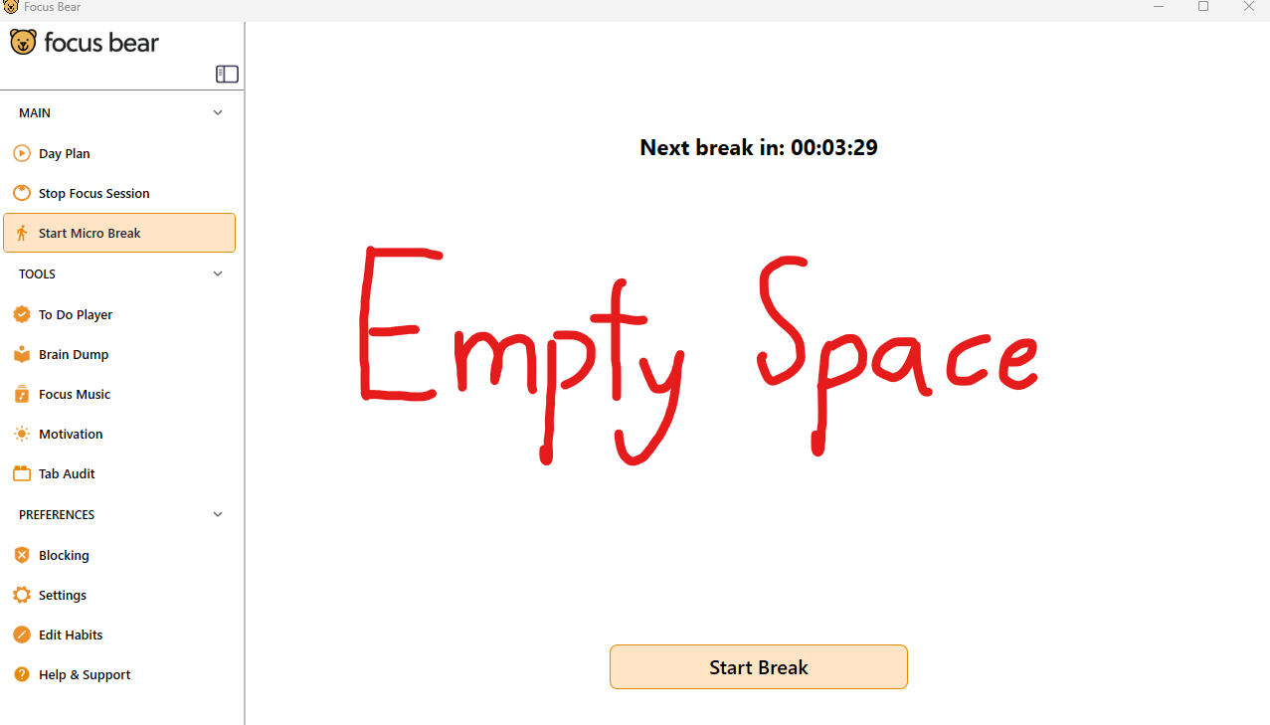
Figure 4 Micro Breaks

- I don’t see a view blocked apps option. I feel that if that is a block list and allow list for websites, there should be the same lists for apps too. I understand I could just allow the apps I want. In that case, why is there a allow list for websites? Wouldn’t it make more sense to edit a block list of apps as opposed to editing an allow list for apps?
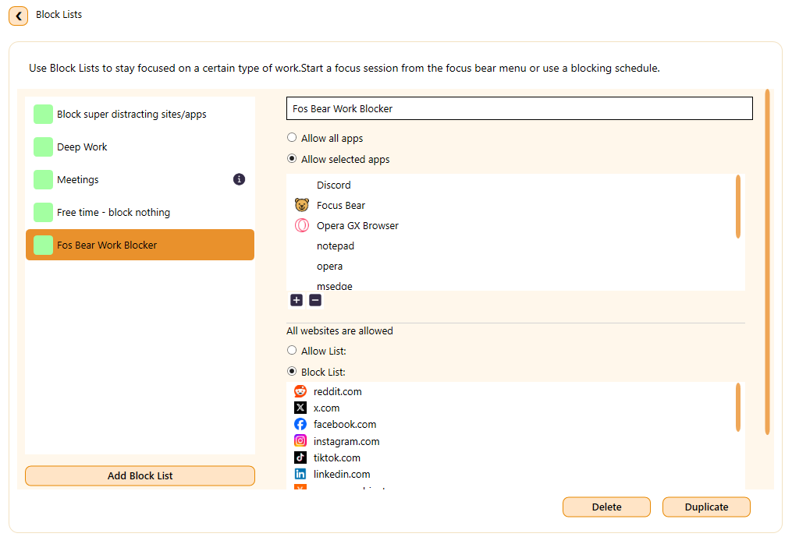
Figure 5 Block list
- When users click on the ‘Stop Focus Session’ button, two small dropdown option will come out. The dropdown options for when I want to pause or stop the focus session is very small. I feel like I could misclick it and select the wrong option. It would be better looking and easier to click on if it’s bigger.
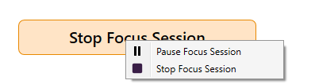
Figure 6 Stop Focus Session

Think about how the onboarding experience could be improved:
In terms how the onboarding experience could be improved for the users, I think having the users set their own block list and habit routines would help. The main point of the onboarding once they have installed the app is to create a block list and create a habit routine. Currently, the users can just rely on AI to create their block list and habit routine from one of the habit packs. This is effective if you want to speed through the onboarding section. However, it doesn’t give the users a chance to understand the app. The onboarding section should also teach users the bare fundamental features of the app. Of course, there is also the problem where people can’t be bother to set up the block list or habit routine. The key point is not to make it faster for them but make it easier for them to set it up.
My suggestion:
For the block list, allow the users to pick from a short selection of apps or websites that they want to block. Make it like a checklist or buttons. It could also be made slightly exciting like making the websites or apps as a balloon to pop. It would make it more engaging.
For the habit routine, allow the users to either create manually or pick one of the habit packs. If they are picking from the habit packs, give a brief one sentence description of the habit pack. Enough for them to understand.
Conclusion
I think we have to make it easier and more engaging for users to go through the onboarding section instead of making it faster. This way, the users can understand the bare fundamental functions of the app without having to read a whole bunch or find the tutorial. Not only that, I think it could increase the active users and keep the user retention more consistently.

